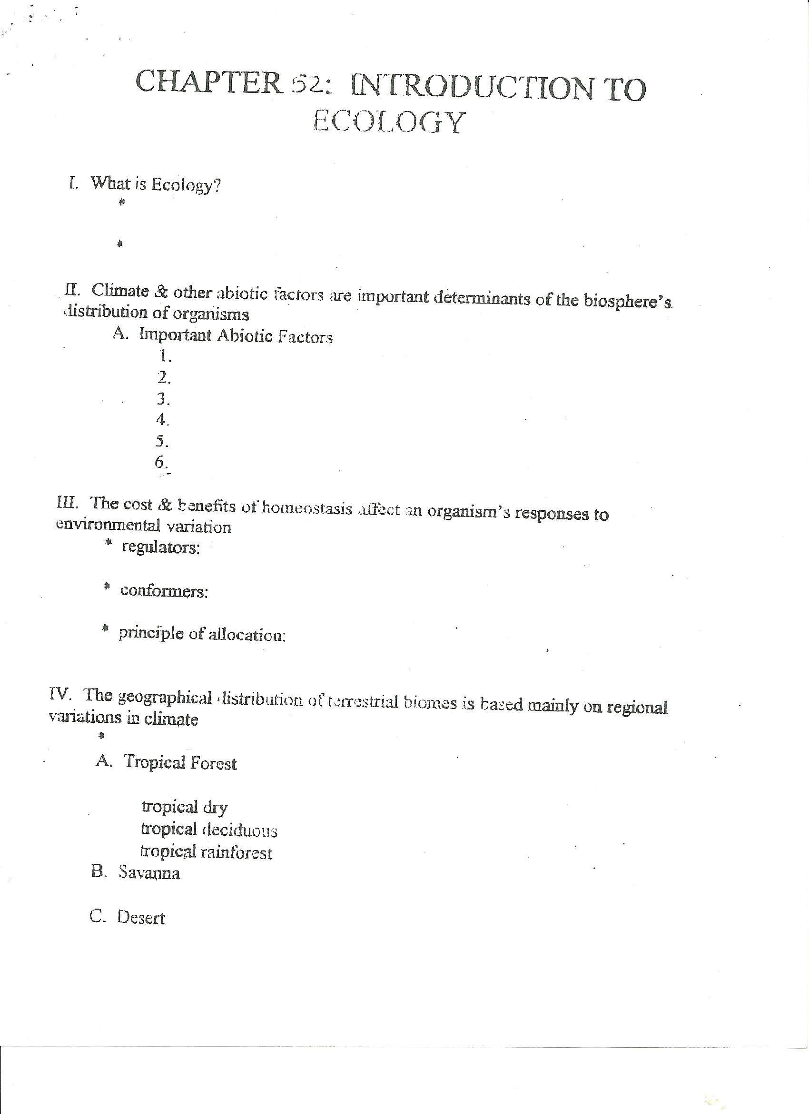
\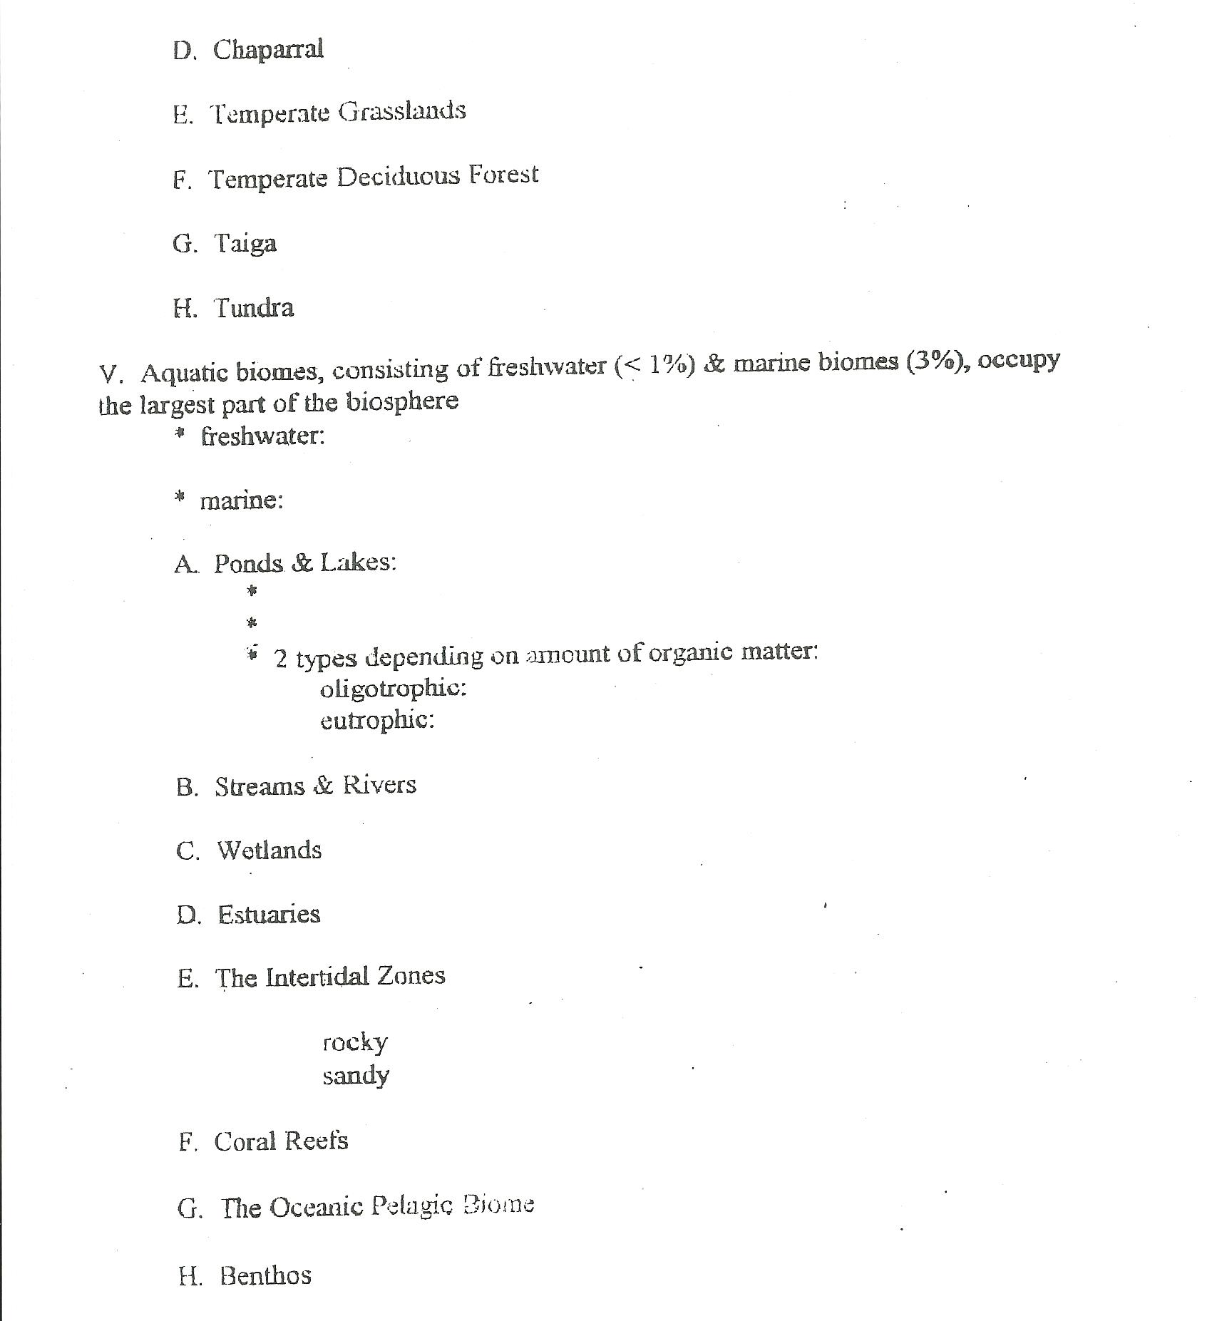
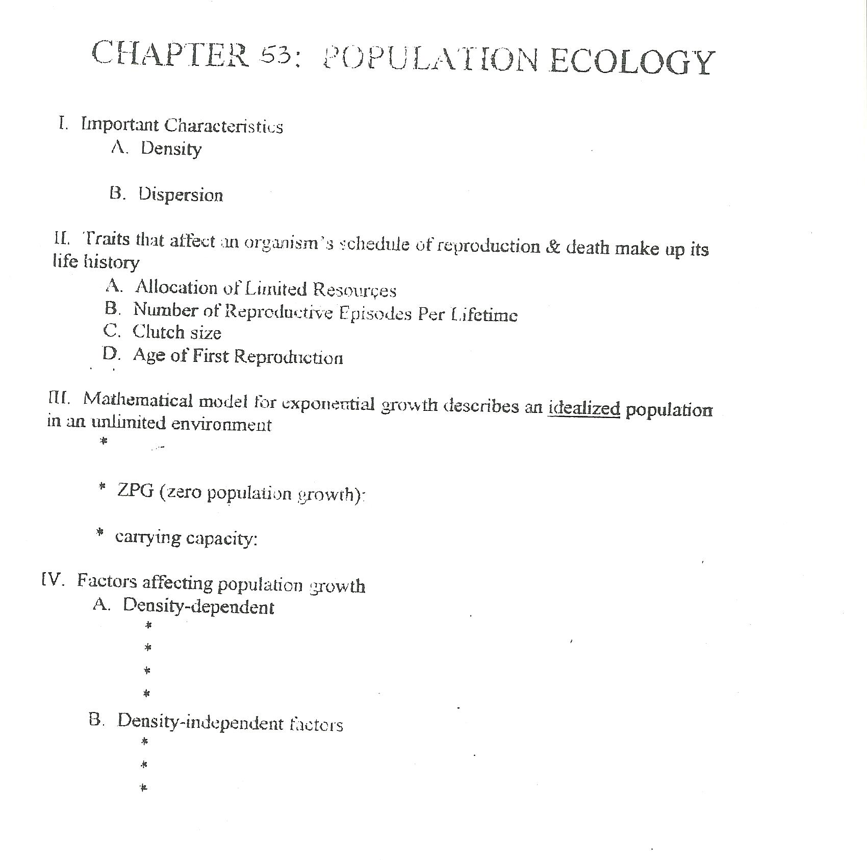
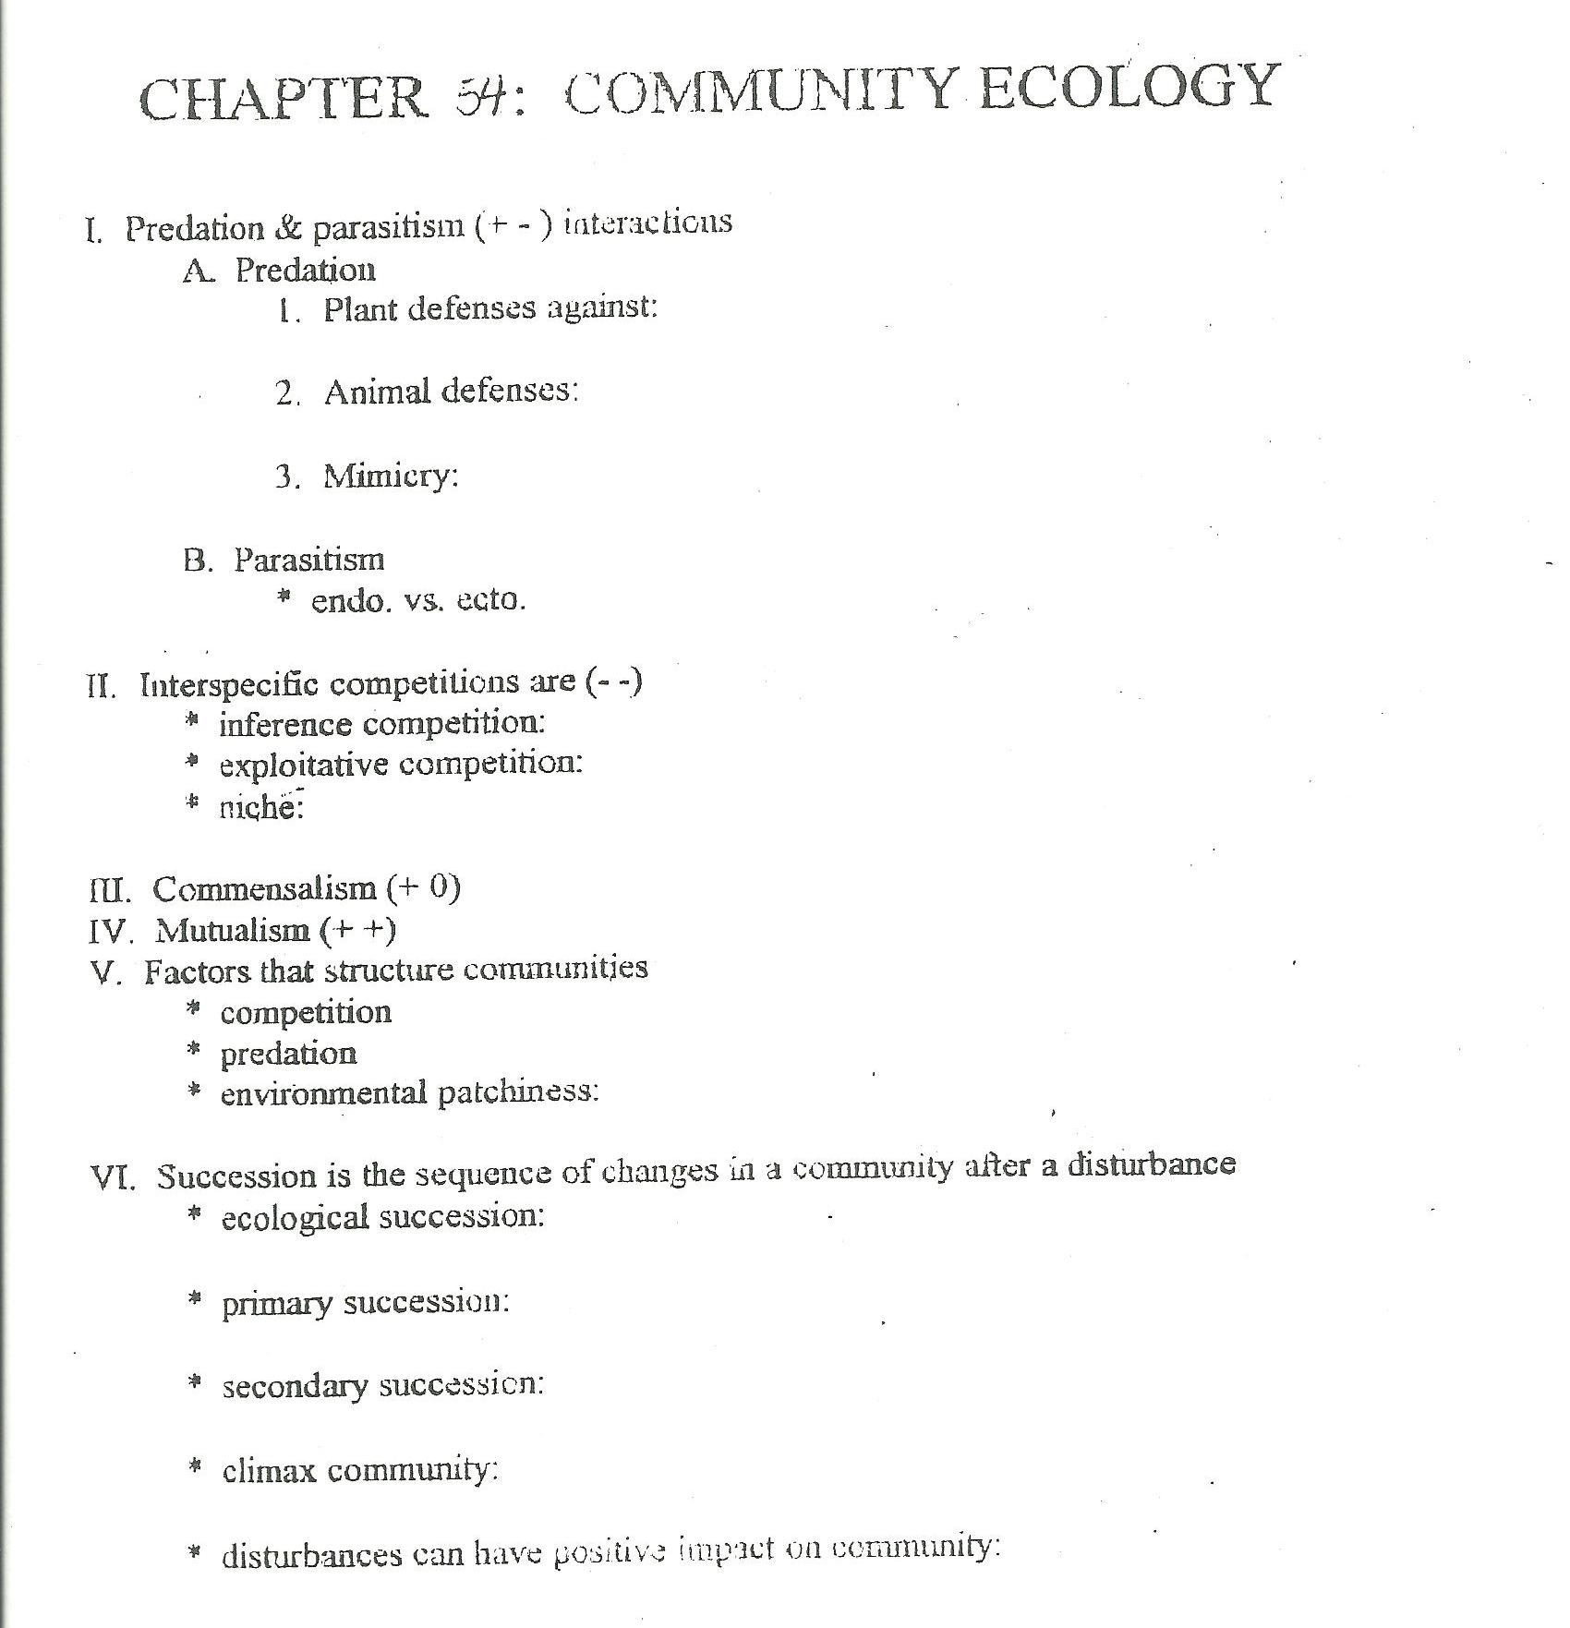
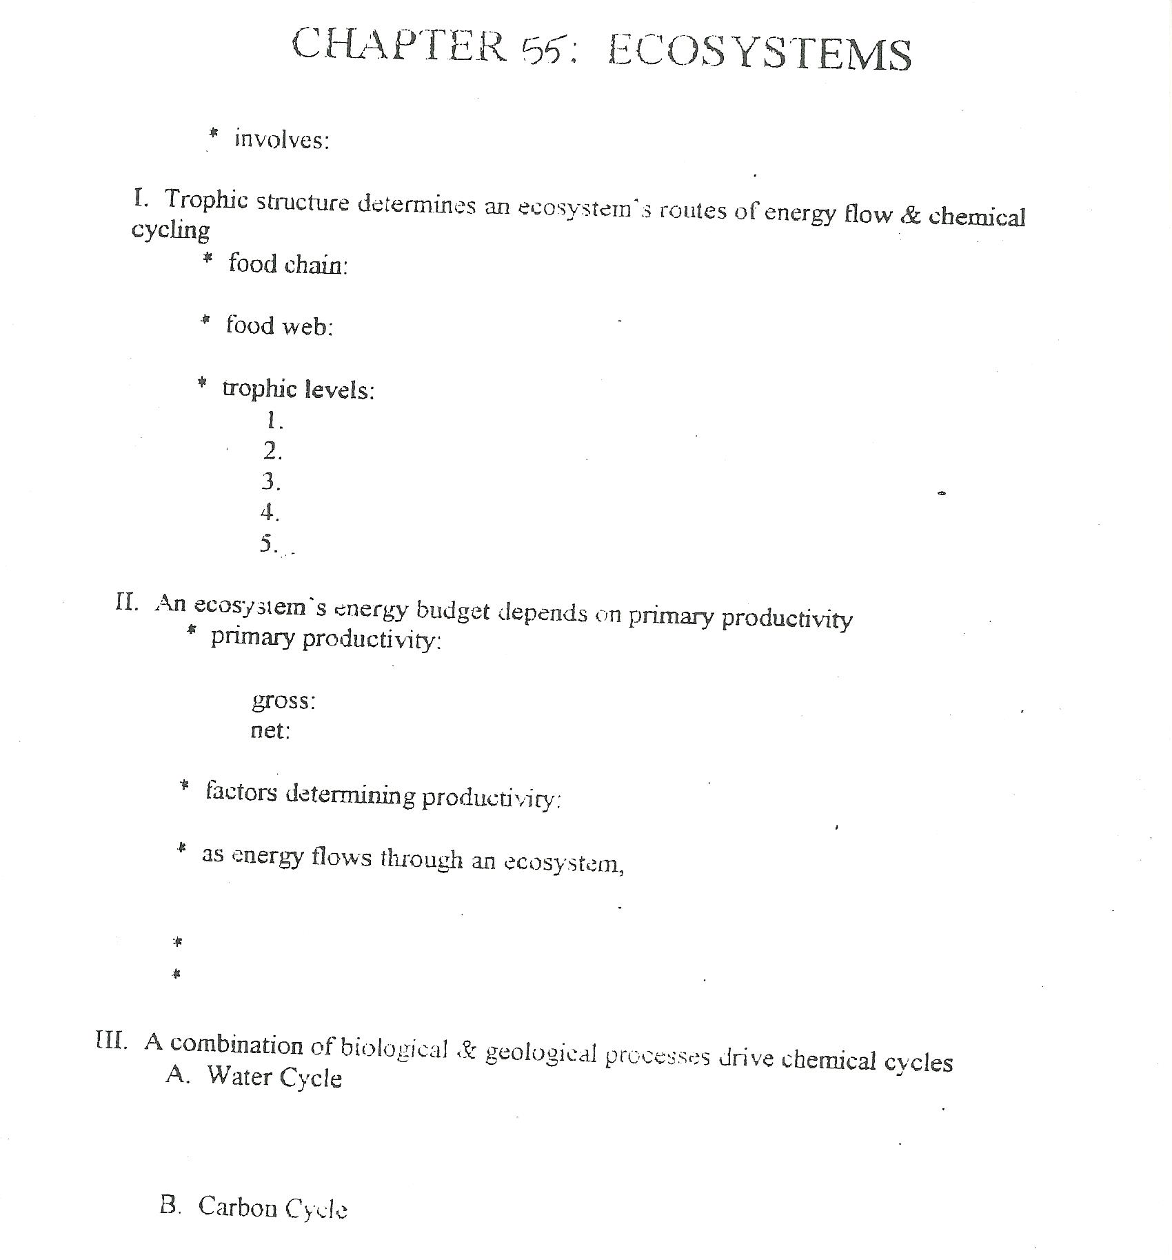
CHAPTER 50: BEHAVIOR
Innate:

Fixed-action pattern:

Nature versus nurture:

Learning versus maturation:

Habituation:

Imprinting:

Classical conditioning:

Operant conditioning:

Observational learning:

Play:

Insight:

Animal cognition:

Kinesis:

Taxis:
Migration:

Competitive social behaviors
Agnostic behavior:
Dominance hierarchy:
Territoriality:

Mating behavior:
Courtship
Mating systems:
Promiscuous:
Monogamous:
Polygamous:
Polygyny:
Polyandry:

Social interactions depending on diverse modes of communication:

Altruistic behavior

