CHAPTER 2-5 & 8 PACKET O’ FUN

CHAPTER 2
- On Earth, mass and weight may be considered synonymous.
  - Define mass.

  - Define weight.

- The difference between the mass number and the atomic number of an atom is equal to the number of ______________________________. An atom of phosphorus, P, contains _________ protons, __________ electrons, and __________ neutrons. The atomic weight of phosphorus is ___________.

- To move to a shell farther from the nucleus, an electron must (absorb/release) energy; energy is (absorbed/released) when an electron moves to a closer shell. (Circle the correct terms.)

- Which of these atoms would you expect to have similar chemical properties? Why?
  - ₇N b. ₁₅P c. ₈O d. ₁₇Cl

- Fill in the blanks in the following concept map to help you review the atomic structure of atoms.

Combine to get

outer shell called

may differ in various

constant for each

located in

determine

have these three subatomic particles

located in the nucleus

ATOMS

- What are the valences of the four most common elements of living matter?
  - hydrogen __________ c. oxygen __________
  - nitrogen __________ d. carbon __________

- Calcium (₂₀Ca) and chlorine (₁₇Cl) can combine to form the salt calcium chloride. Based on the number of electrons in their valence shells and their bonding capacities, what would the molecular formula for this salt be? a. _________________ Which atom becomes the cation? b. _________________

- Sketch a water molecule, showing its shape and the electron shells with the covalently shared electrons. Indicate the areas with slight negative and positive charges that enable a water molecule to form hydrogen bonds.

- Fill in the missing coefficients for respiration, the conversion of glucose and oxygen to carbon dioxide and water, so that all atoms are conserved in the chemical reaction.
_______ C₆H₁₂O₆ + _______ O₂ _______ CO₂ + _______ H₂O

- Fill in the following chart for the major subatomic particles of an atom.
Particle | Charge | Mass | Location

- Atoms can have various numbers associated with them: atomic number, mass number, atomic weight, valence
  - How is the mass number different from the atomic weight?

  - Define valence.

  - Which of these four numbers is most related to the chemical behavior of an atom? Explain.

- Explain what is meant by saying that the sharing of electrons between atoms falls on a continuum from covalent bonds to ionic bonds.

CHAPTER 3
- Fill in the following table that summarizes the properties of water that contribute to the fitness of the environment for life.
Property | Explanation of Property | Example of Benefit to Life
a. | Hydrogen bonds hold molecules together and adhere them to hydrophilic surfaces. | b.
High specific heat | c. | Temperature changes in environment and organisms are moderated.
d. | Hydrogen bonds must be broken for water to evaporate. | e.
f. | Water molecules with high kinetic energy evaporate; remaining molecules are cooler. | g.
Ice floats | h. | i.
j. | k. | Most chemical reactions in life involve solutes dissolved in water.

- A patient has been vomiting for a prolonged period of time.
  - What effect would this have on the [H⁺] in the blood?

  - How will the bicarbonate buffer system respond to this change?

  - What effect will the buffer system response have on the rate of respiration?

CHAPTER 4
- Fill in the following table on the functional groups.
Functional Group | Molecular Formula | Name and Characteristics of Organic Compounds Containing Functional Groups
 | -OH
 |  | Aldehyde or ketone; polar group
Carboxyl

 | -NH₂
 |  | Thiols; cross-links stabilize protein structure
Phosphate

CHAPTER 5
- Phospholipids can self-assemble in an aqueous environment into a rounded droplet called a micelle. Sketch a micelle, and label the hydrophilic head and hydrophobic tail of one of the phospholipids.

- a. Why could a change in pH cause a protein to denature?

b. Why would transfer to a nonpolar organic solvent (such as ether) cause denaturation?

c. A denatured protein may re-form to its functional shape when returned to its normal environment.
What does that indicate about a protein’s conformation?

- Describe the four structural levels in the conformation of a protein.
*

*

*

*

- Fill in the concept map using the word bank below.

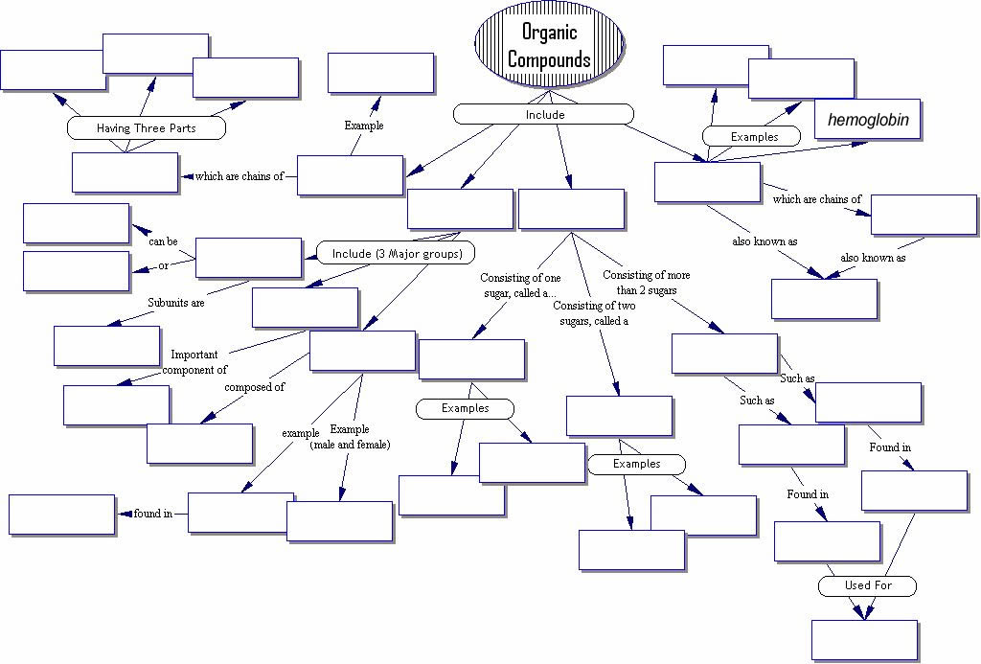

WORD BANK
Amino acids, animals, Carbohydrates, Cell membrane, Cholesterol, DNA, Disaccharide, Egg yolk, Energy storage, Enzymes, Fats, Fatty acid, Fructose, Glucose, Glycogen, Hemoglobin, Hormones, Insulin, Lactose, Lipids, Monosaccharide, Nitrogen Base, Nucleotide, Nucleic Acids, Phosphate Group, Phospholipid, Plants, Polypeptides, Polysaccharides, Proteins, Saturated, Starch, Steroids, Sucrose, Unsaturated, 4 rings of carbon, 5 carbon sugar

CHAPTER 8
- a. Where is the region of instability in a molecule of ATP? Why is it unstable and by what chemical mechanism is the bond broken?

b. Why is energy released?

- Relate the concept of free energy to metabolism.

- What role do enzymes play in metabolism?

