CLADOGRAMS AND PHYLOGENETIC TREES

Cladistics is the study of evolutionary classification. Cladograms show evolutionary relationships among organisms. Comparative morphology investigates characteristics for homology and analogy to determine which organisms share a recent common ancestor. A cladogram will begin by grouping organisms based on a characteristics displayed by ALL the members of the group. Subsequently, the larger group will contain increasingly smaller groups that share the traits of the groups before them. However, they also exhibit distinct changes as the new species evolve. Further, molecular evidence from genes which rarely mutate can provide molecular clocks that tell us how long ago organisms diverged, unlocking the secrets of organisms that may have similar convergent morphology but do not share a recent common ancestor.

Big Idea 1: The process of evolution drives the diversity and unity of life.
Essential Knowledge 1.B.2: Phylogenetic trees and cladograms are graphical representations (models) of evolutionary history that can be tested.

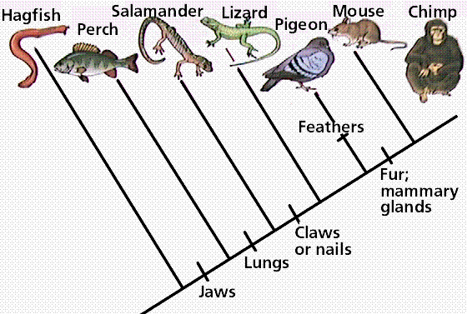

- Which organisms in the cladogram in Figure 1 have fur and mammary glands?

- Which organisms in the cladogram in Figure 1 have jaws?

- Based on the cladogram in Figure 1, which shared a common ancestor most recently – a mouse and a lizard or a mouse and a perch?

- Which two organisms would you expect to have a closer matching DNA sequence for a gene that is NOT under selective pressure in nature – Hagfish and Pigeon or Hagfish and Salamander?

Part I: Morphological Evidence: Using your text and prior knowledge, determine the morphological characteristics of the organisms in the following table. For every characteristic the organism possesses, put a check in that box. The table is partially completed for you.
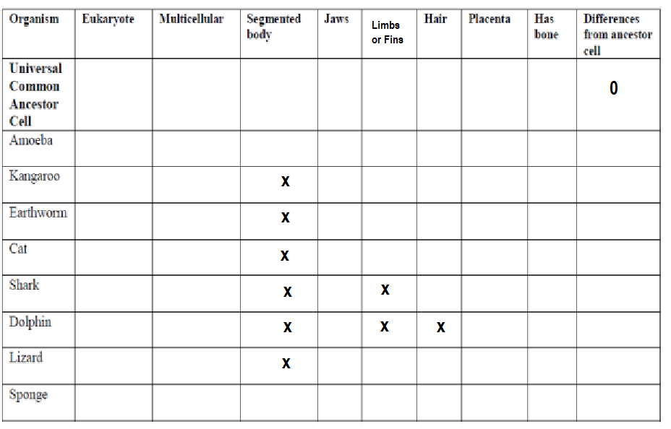

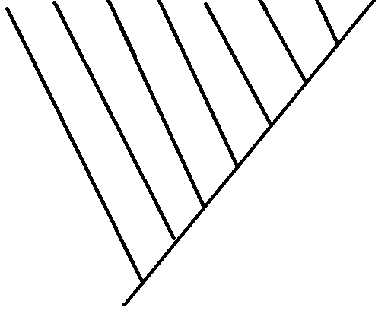

Part II: Molecular Evidence: Cytochrome c is a protein located in the mitochondria of cells involved with cellular respiration. Compare each organism’s cytochrome c DNA sequences with the ancestor cell and each other. Circle or highlight the differences (mutations) present in the cytochrome c DNA sequences from ancestor cell.
Cytochrome c DNA Sequence Data
Organism | DNA Sequence | # of mutations
Ancestor  Cell | A T T A G C G A C C A G T A T A T C C T A C A A T C C G T C T A C T T C A T T | 0
Amoeba | A T T A G C G A C C A G T T T A T C C T A C A A T C C C G T C T A C T T C A T
Kangaroo | C T A A T C C C C C C G T T T A T C C T A C T T T C C C A T C T A C T A A G T
Earthworm | C T T A T C G A C C C G T T T A T C C T A C A T T C C C G T C T A C T T C G T
Cat | T T A A T C C C C C C G T T T A T C C T A C T T T C C C A T C T A C T A A G T
Shark | C T T A T C C C C C C G T T T A T C C T A C T T T C C C G T C T A C T T C G T
Dolphin | C T A A T C C C C C C G T T T A T C C T A C T T T C C C A T G T A G T A A G T
Lizard | C T A A T C C C C C C G T T T A T C C T A C T T T C C C G T C T A C T T C G T
Sponge | A T T A T C G A C C A G T T T A T C C T A C A T T C C C G T C T A C T T C G T

- How did you morphological cladogram compare with your cladogram based on the cytochrome c DNA evidence?

- a. Compare and contrast convergent evolution with divergent evolution.

b. Which two organisms show convergent evolution in the cladogram above?

c. Why might these two organisms have similar morphology despite not sharing a recent ancestor?

- Which type of evidence for evolution is most accurate in determining evolutionary relationships – morphology or molecular? Why?

- Phylogeny is the evolutionary history of a species.

- The evolution of a species is dependent on changes in the genome of the species. Identify TWO mechanisms of genetic change, and explain how each affects genetic variation.

- Describe TWO types of evidence – other than the comparison of proteins – that can be used to determine the phylogeny of organisms. Discuss a strength of each type of evidence you described.

- Explain why more closely related organisms have more similar cytochrome c.

- What is the main difference between a cladogram and a phylogenetic tree?

- List four characteristics of the universal common ancestor.

